Knox County Highway Department

Monthly Newsletter
  - October 2018
Birthdays
Tracy Lockhart 10/1
Milo Green 10/17
Jamie McCrary 10/25

Anniversaries
Ethan Clark 10/7 (3 yrs)
Johnny Rinsch 10/7 (3 yrs)
Rick Pritchard 10/12 (8 yrs)
Brian Phillips 10/24 (7 yrs)

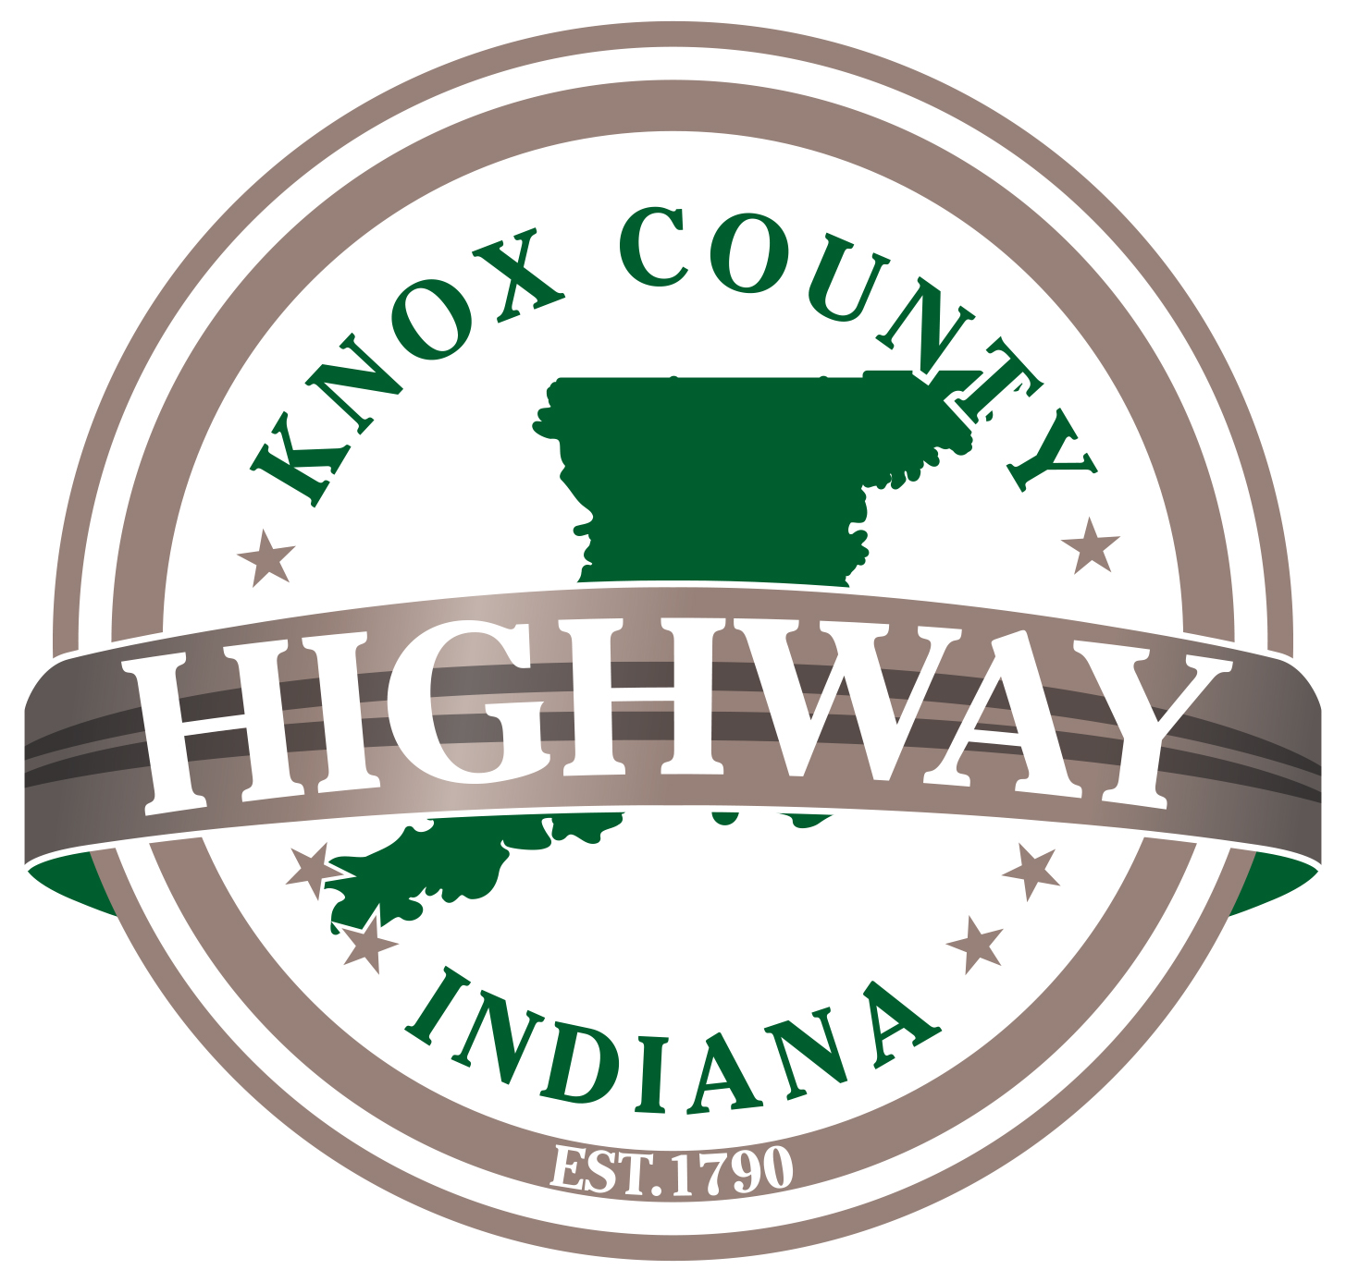

Wellness Nurse
October 18, 2018
2:00pm – 3:30pm
“You can’t have a million-dollar dream
with a minimum wage worth ethic.”
“Thank you for paving Hillcrest Road! It makes such a smooth drive!! I’m sure it was very hot and miserable out there yesterday. Your hard work is much appreciated!!” - Jeanette Andrews
“Thank you for the speedy response and a job well done on
Main Street Road.” - Tammy

Holidays
10/8 – Columbus Day (Paid)
10/31 – Halloween (Unpaid)

Safety
From 2011 to 2015, 609 workers were killed from injuries at road work zones in the United States. These work zones include construction, maintenance, or utility work on a road, street, or highway. Indiana had 25 fatal injuries within this 5 year.

About 46 percent of these workers were killed in pedestrian vehicular incidents, which include being struck by a vehicle or mobile equipment. Workers were most frequently struck by automobiles or dump trucks. Of the 79 workers struck by an automobile, the automobile was moving forward in 72 cases. Of the 49 workers struck by a dump truck, the dump truck was backing up in 40 cases.

