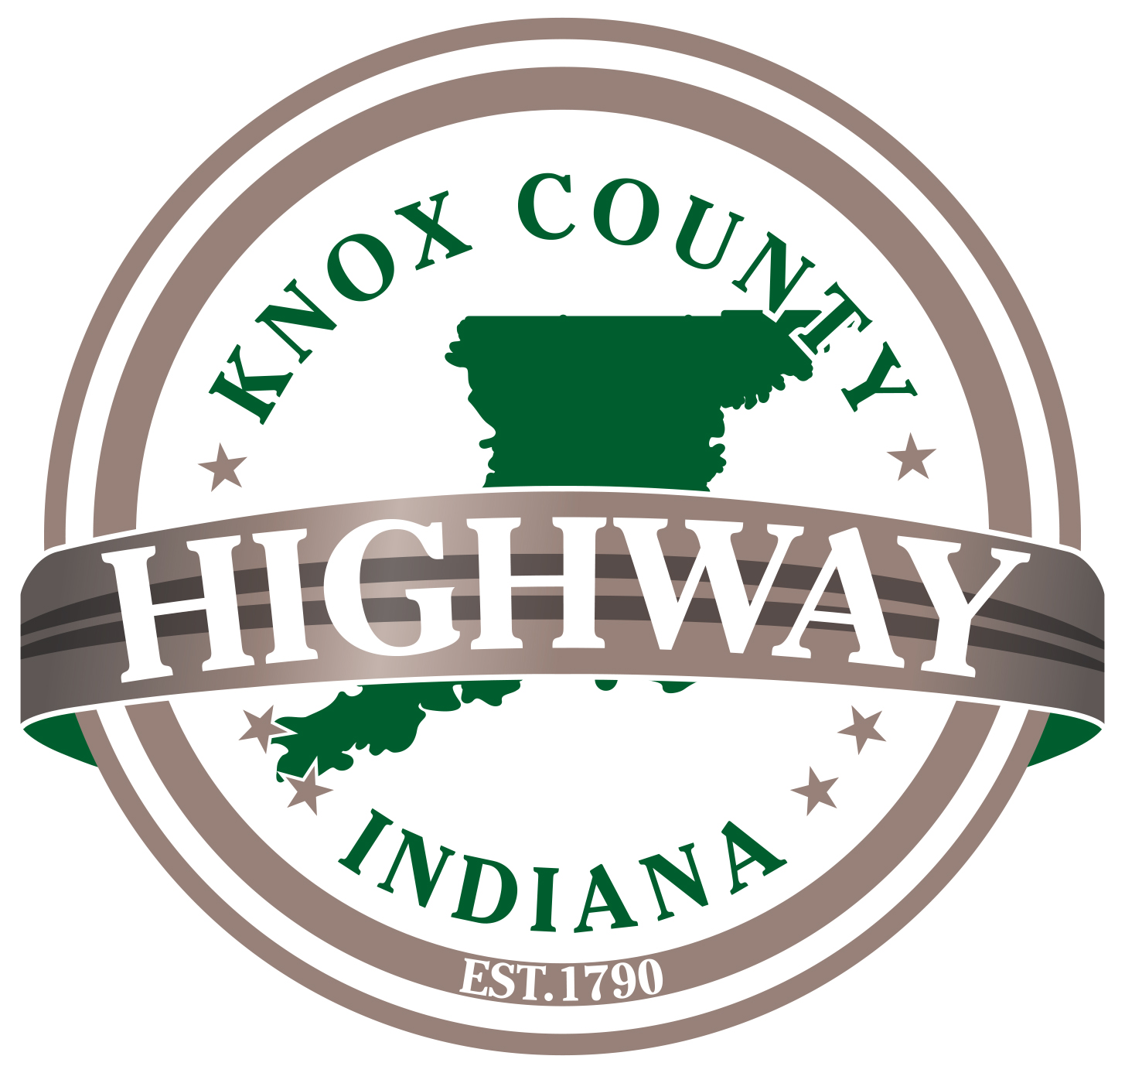

Knox County Highway Department

Monthly Newsletter
  - August 2020
Birthdays
Bill Goodman 8/7
Frank Woolard 8/8
Benji Boyd 8/11
Brian Meek 8/21

Anniversaries
No Anniversaries

Wellness Nurse
August 20, 2020
1:00pm – 2:30pm
“You will never win if you never begin.”

Holidays
No Holidays

All Districts including the shop, showed great teamwork and unity while doing a fantastic job Cold Mixing several roads like River Road in District 3 and Lincoln Lane in District 1 to name a few.
EVERY TUESDAY AND THURSDAY
@ 2:45 WEATHER PERMITTING
Subject to Change

2021 Budget preparations are well under way to reach the July 31, 2020 deadline.

